Shabbos Stories for
Parshas Bo 5781
Volume 12, Issue 21 10 Shevet/January 23, 2021
Printed L’illuy nishmas Nechama bas R’ Noach, a”hs

For a free subscription, please forward your request to keren18@juno.com
Past stories can be found on the website ShabbosStories.com

The Group of 12 vs.
The Russian Poet
By Elchonon Isaacs
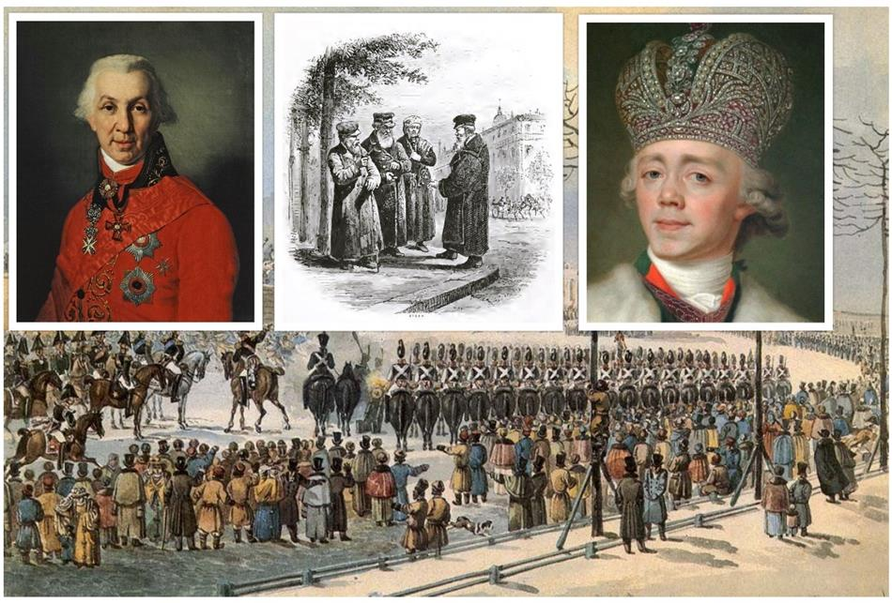
In addition to disseminating Chassidic teachings, Rabbi Shneur Zalman of Liadi, the Alter Rebbe, founder of Chabad Chassidism, worked methodically and discreetly to protect and improve the welfare of Jews living in Russia.

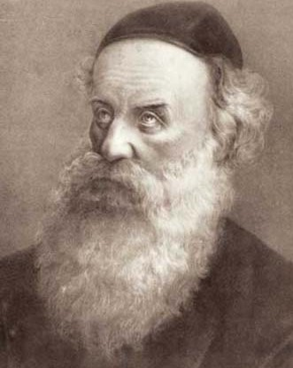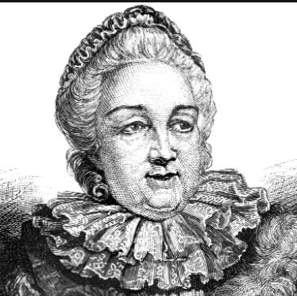
Rabbi Shneur Zalman of Liadi, zt”l Catherine the Great (yemach shemo)

This began shortly after Catharine the Great took up her position in 1772, and Jews were granted citizenship rights. The Rebbe chose twelve wise and successful Chassidim to relocate to the capital city of Petersburg, where they were to establish contacts with various government officials in the course of their business dealings.
The purpose was twofold: to gather information about the government’s agenda, and to establish diplomatic avenues to help prevent or annul any new decrees that could harm the Jewish people. This group of twelve worked seamlessly together in a clandestine way. They would transmit information back to the Rebbe, who was in Liozna, and over the years quite a few evil decrees were subverted.
In 1794, following the conquest of Poland, Russia found itself with millions of additional Jewish denizens, and many agitated for new laws restricting Jews and their business activities.
The group got wind of these initiatives and with great effort they tried, unsuccessfully, to block them from getting to the interior minister.
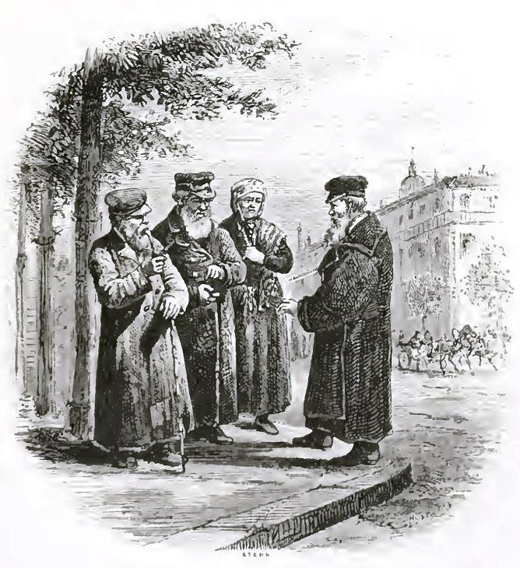
Illustration photo (Wikimedia Commons).

The Empress agreed to have the complaints investigated and assigned her interior minister to commission a study investigating how the Jews lived throughout Russia, Poland, Ukraine, and Lithuania, and to see if there was any merit to the libelous claims against them. The author of the study would write up his conclusion and his recommendations would be implemented.

The minister instructed his deputy, Nikitin, who was known to be a corrupt and vile individual, to get the report underway. Nikitin commissioned the famous poet Gavrila Derzhavin, a notorious anti-Semite, whose opinions were highly regarded in the Czar’s circle. All this was cause for great concern.

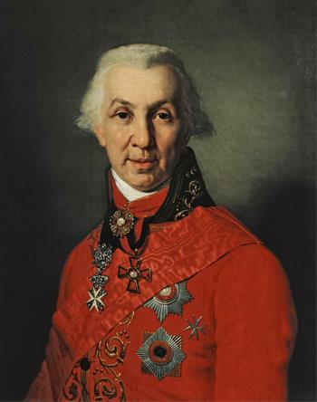
Portrait of Gavrila Romanovich Derzhavin (1811), by Vladimir Borovikovsky.

Dovber Moshe of Disna, a member of the group, knew Derzhavin from his youth. And when Dovber Moshe moved to Petersburg,
Derzhavin met him on the street, recognized him, and invited him to his home.
During their many chats, the topic of Jew-hatred frequently came to the fore. Dovber Moshe would demonstrate how whichever claims were currently circulating regarding Jews were unfounded, and Derzhavin's default answer was, “If only all your Jewish brothers were like you, I’d like them, or at least not hate them.”

The Obvious Choice
To Meet Derzhavin
This relationship made Dovber Moshe the obvious choice to meet with Derzhavin to convince him to carry out the study fairly and objectively.
At the meeting, Derzhavin told Dovber Moshe that the Empress had instructed the interior minister to ensure that the study would be done by someone who would not sell out the motherland to those who hate her religion and that of her citizens.
He should relegate the “wise nation” to jobs they deserve. “I intend to do my work impeccably,” Derzhavin concluded, “and you, my old friend, and all the Jews in Petersburg should start packing, as my first recommendation will be to expel all Jews from the capital.”

******************************************************************
This predetermined conclusion did not leave room for much hope, and any attempt at persuading his old friend seemed futile. Dovber Moshe relayed the information to the group, and together they decided to keep the meeting a secret from the public, and chose Dovber Moshe to pass on the information to the Rebbe.
The Rebbe instructed the group to obtain Derzhavin’s itinerary and travel dates, and to continue working diligently to keep all avenues open. As for Derzhavin’s threat to expel the Jews from the capital, the Rebbe wrote on a piece of paper: “One who girds [the sword] shall not boast like one who ungirds [the sword], but the victory is the L-rd’s.”¹

Dovber Moshe managed to obtain the requested information and relayed it to the Rebbe.
Shmarya Zalman of Polotzk, a silk merchant, and Nosson of Shklov, a diamond merchant, were nominated by the Rebbe to follow Derzhavin’s itinerary and establish contacts with local government officials and landowners along the way. They were to spare no effort obtaining any scrap of information about Derzhavin and his meetings and to document any impropriety.
The pair managed to obtain the information they sought, and compiled a detailed ledger with notes of meetings where hostile expressions were used, names and dates of those who were bribed, and more.

The Empress Dies and
Her Son TakesOver
During Derzhavin’s trip, the Empress died and her son Paul took over. Paul was a good ruler who prioritized stability and surrounded himself with people of integrity. He made sweeping changes in his cabinet which was reflected in the mood on the street and the attitude towards Jews improved. The group remembered what the Rebbe had written on the piece of paper and they attributed the changes to that.

Paul I of Russia (1800), by
Vladimir Borovikovsky

Meanwhile, the Rebbe gave the ledger that Shamrya Zalman and Nosson had compiled to Moshe Vilenker and Moshe Meizels. Their job was to organize the content, bring it to Petersburg, and together with the rest of the group find a way to get the ledger to the ministers who were friendly with the Jews.
When they arrived, they heard that Derzhavin was compiling his report. Taking no note of the changes that had taken place in the palace, Derzhavin submitted his scathing report. In his personal statement, he noted that he believed he had fulfilled his duties to the best of his abilities, just as the late Empress had instructed him.
Little did Derzhavin know that on Paul’s desk sat the ledger submitted by Moshe Meizels and Moshe Vilenker in advance of his own. The Czar thoroughly rebuked Derzhavin and then tossed the dossier into the fire, lifting the plight of the Jews.
Adapted from the diary of the Previous Rebbe, Rabbi Yosef Yitzchak Schneersohn. Reshima #8 pp. 23-27.
FOOTNOTES
1. A conflation of Kings I 20:11 Proverbs 21:31.

Reprinted from the Parshat Vayechi 5781 email of Chabad.Org Magazine.

Everything is a Miracle
By Rabbi Dovid Goldwasser

The Ramban tells us that at times we are privileged to experience open miracles in order to strengthen our faith in Hashem’s hashgacha of the world. Acclaimed miracles enable us to more easily recognize the hidden miracles of natural law.
The Talmud (Taanis 25a) relates that one Shabbos evening, R’ Chanina ben Dosa saw that his daughter was sad. When he questioned her, she said that she had mistakenly lit the Shabbos lamps with vinegar instead of oil, and she was concerned that they would soon go out.
R’ Chanina exclaimed, “What are you concerned about? He Who decreed that oil should burn can decree that the vinegar should burn.” And so it was. The lamps burned through the Shabbos and were still burning for Havdalah.
The Ben Yehoyada (also known as the Ben Ish Chai, 1832-1909) asks: As soon as the daughter of R’ Chanina saw the wicks burn steadily despite being immersed in vinegar, she knew an open miracle had occurred. Why, then, was she sad?
He answers that she knew she was seeing a miracle and, indeed, the household of R’ Chanina ben Dosa were accustomed to experiencing miracles. She feared, however, that they would have to sit in the dark over Shabbos since it’s forbidden for one to benefit from a miracle.

Her father explained, however, that their emunah in Hashem was so absolute that it made no difference to them how the lamps remained lit since without the command of Hashem a wick would never burn steadily – whether it was immersed in oil or vinegar. Both were equal miracles to R’ Chanina. One who attains such a level of emunah may undoubtedly enjoy the light that comes from a wick immersed in vinegar, as Chabakuk 2:4 says, “The righteous person shall live through his faith.”
It was an “off-Shabbos” in one of the yeshivos in Israel, which meant that the students could go home for Shabbos. Two of the young men from abroad who had no family in Israel decided to spend Shabbos in Tzfas where they would have an opportunity to visit some of its holy sites. They made the necessary arrangements and took an early bus out of Yerushalayim to ensure their timely arrival in Tzfas.

Hashem Had Other Plans
But Hashem had other plans. There were many delays along the way, and close to candle-lighting time they were still in Teveriah. The young men realized that they would have to find accommodations somewhere in the city. They approached one of the houses, and, when they knocked on the door, they were immediately invited in.
“I have everything you need,” said the host graciously, “and it would be my honor to have you stay with me for Shabbos.” The man was very congenial and hospitable, and the boys thanked him from the bottom of their hearts for his invitation. The guests couldn’t help notice that many of the bedrooms in the house had children’s toys in them. “Where are the children?” they asked.
Their host laughed and responded, “Indeed, if you would have come any other Shabbos, I would not have had any beds for you because they are all for my children.” He then explained that two weeks earlier he had to travel out of the country and made arrangements for his children to stay with a different family in another city. Due to circumstances beyond his control, he had to stay away longer and he didn’t have time to pick up his family when he got back because his flight was delayed.

The Story Doesn’t End There
The boys immediately recognized the auspicious turn of events that Hashem had orchestrated. But the story doesn’t end there. Two weeks later, a shidduch was suggested to one of the young men with the daughter of their host. The man had observed the exemplary middos of the young man and realized he would be a perfect match for his daughter.
It was at that point that they grasped the true extent of Divine Providence in this world – “By Hashem are man’s footsteps established” (Tehillim 37:23).

Reprinted from the December 18, 2020 edition of The Jewish Press.
A Wedding Feast
For Everyone
By Shloimy Weber
(shloimy.yweber@gmail.com)

When Rav Mattisyahu Salomon and family moved to Lakewood, they quickly developed a close friendship with their neighbors, the Epsteins. When one of the Salomon girls got engaged, the Epsteins were thrilled and couldn’t wait to dance at her wedding. Sadly, Rabbi Epstein passed away a few weeks after the engagement. The Epsteins were plunged into mourning, and knew that attending the wedding would be out of the question.
On the day of the wedding, the Epsteins came home to find a note that read, “To our dear friends, the Epsteins: Please do not prepare dinner this evening. Your dinner will be served to all of you shortly. We will miss you at the wedding, but we wanted you to share in our happiness, so the caterer will be at your home with the wedding meal shortly. May we share future simchas, the Salomons.”
A truck soon arrived from the wedding hall, bringing the full meal, including dessert, for the whole family. Not only that, but the Salomons sent someone with fresh photos from the wedding, so the Epsteins could enjoy the wedding while they ate the wedding feast! Although the Epstein’s weren’t literally by the wedding, the Salomon’s, who were obviously busy with a million different other things, did not leave them out.
Comment: Parsha Vayigash lists everybody who went down to Mitzrayim. The reason the Pasuk (Bereishis 46:6) did this is to teach us to never leave somebody else out, or forget about others. May we always remember this important rule, and always think about others, rather than only ourselves.

Reprinted from the Parshas Vayigash 5781 email of Torah Sweets Weekly edited by Mendel Berlin.

How NY Sanitation Workers Helped One Jew Go Dumpster Diving for His Lost Tefillin

(JTA) — It happens more often than you’d think.
Someone mistakenly puts a ring, a wallet or a purse in the trash and assumes it’s gone forever.
This week, the New York City Sanitation Department helped an Orthodox man in Brooklyn retrieve his tefillin, a Jewish religious object worn during morning prayers, before they were taken to a dump and lost for eternity.
Tefillin can cost hundreds if not thousands of dollars and are used daily for prayer, making them especially frustrating to lose. But even more important, they contain small scrolls inscribed with Torah verses that include G-d’s name and therefore must to be disposed of via burial, much like a Torah scroll or other holy books.
That may have made it worth it to the man who lost the tefillin to search through bag after black garbage bag of trash in the hopes of finding the phylacteries.
Customers who want to retrieve something they’ve thrown away are often able to do so, said Belinda Mager, a spokesperson for New York City’s Sanitation Department. But they have to get in touch with the department quickly and will have to don a jumpsuit and search for the item themselves. Sanitation workers will help direct searchers to the area where the trash closest to their spot was dumped at a transit center.
“You have to call us the same day, but you’d be surprised at how many items are found,” Mager said.

New York City's Sanitation Department helped retrieve a man's lost tefillin this week. (New York City Department of Sanitation)

This wasn’t the first time the department helped someone find a lost pair of tefillin. But, Mager said, it was especially heartwarming to be able to find the tefillin this week, at the close of a year of so much loss.
“It’s really nice when we can make it work because you think, well if I threw something in the trash, it must be gone forever. Well, not necessarily, we have a fair amount of these lost and founds,” Mager said. “There’s a happy feeling.”

Reprinted from the December 22, 2020 dispatch of the JTA (Jewish Telegraphic Agency)
A Russian Doll and an Unlikely Legacy of Kindness
By Sofya Tamarkin

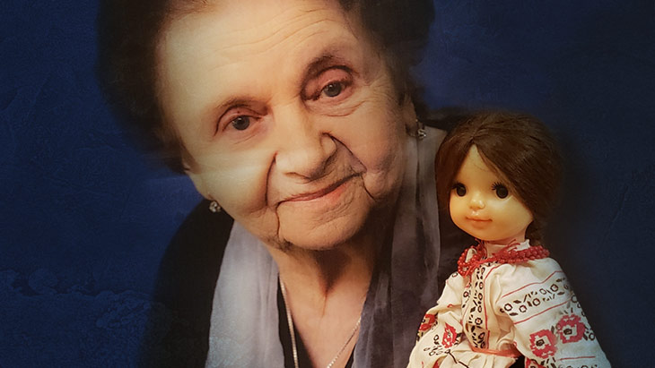
A true story that we need to hear during these difficult times.

My grandmother, Zelda, was born in July, 1924 in a city called Samara on the Volga River in the former Soviet Union. There was so much despair, hunger and poverty after the World War I and the Communist Revolution of 1917. Her mother died when she was just three, during the birth of her younger sister. Her oldest sister, Rachel, was five at the time.
The three sisters were raised by their loving and forever exhausted father, David, who worked around the clock to feed his three daughters.
There were not many real toys back then in the Soviet Union. Children made their own dolls out of old rags, carrying them around as if they were real babies.
Growing up, I loved hearing my grandmother tell me stories about her childhood. This story, which I will retell using my grandmother's voice, is one is my favorite:
One day, I drew a face on an old piece of cloth, stuffed it with grass and made a baby to play with. We had a neighbor, a girl my age named Olya from a Jewish family living nearby. They were a real family with a mother and a father. When we were about 7 or 8, this girl's parents bought her a real doll. It had arms and legs and even hair. It was made out of plastic and had beautiful eyes.
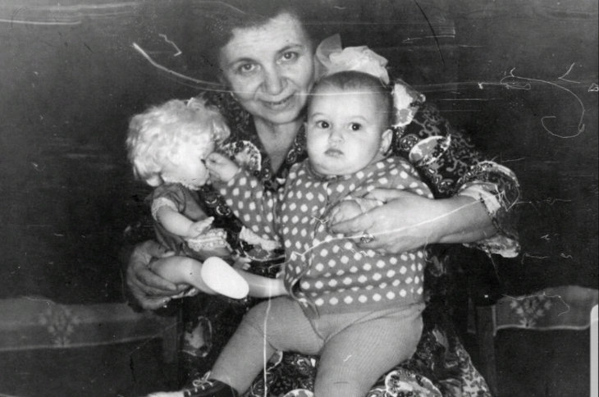

Olya always carried it with her, making sure that everyone knew that she had a real doll. She kept on walking by our house showing off her doll. I pretended not to pay attention, as if I didn't care. Of course I cared, but I didn't want her to know how much I wished I had a real family and a real doll to play with.
She must have been very annoyed that I was ignoring her, so she ran up to me and in a teasing voice said, pointing at my rag doll, “Your doll is not real!”
I wasn't going to take her insults. "And yours isn't real either... it's not a real baby. It's plastic!”
She became very mad and pulled my handmade doll out of my hands. It ripped open and the grass fell to the ground. She kept screaming, “It's not real, it's not real!”
Well, I knew how to stand up for myself. I didn't have a mother to save me, my father was always busy, so I had to fend for myself. I grabbed her toy out of her hands, yelling, “This is fake!” and yanked the hands off the doll. A real calamity for an 8-year-old girl.

Her Parents Came to
Talk to My Father
Her parents came over to talk to my father about the "incident" that evening. I was embarrassed for my defiance.
They were very angry and demanded that Papa pays for the damage that I caused. This doll was expensive. Then they saw the exhaustion on Papa's face and his reluctance to argue. He was raising three daughters alone, without a wife to lean on.
I think they realized that Papa had no energy to fight with them and told him not to worry about it. A few days later they returned with a little toy for me. These were kind and empathic people who understood our family's despair.
Years later I ended up in the same medical school class as that girl, Olya, during the World War II. We were both embarrassed about what had happened and laughed about it. Olya and I had fought side by side to save the lives of wounded soldiers during the war. We had to heal real legs and arms on real soldiers, not the plastic ones.
Olya's generous and kind parents taught me that there is no point in being bitter.

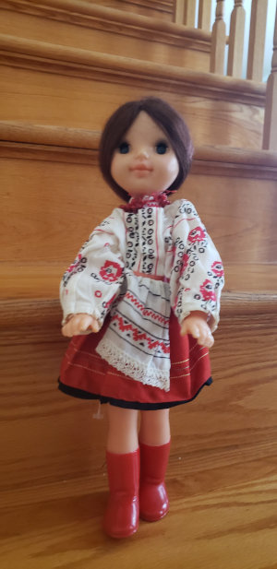
This past May, my grandmother passed away at the age of 95. I thought about her and the unforgettable kindness of Olya's parents when I recently stopped by a Goodwill store in Philadelphia. As I entered, I noticed a doll calling me with her plastic eyes. I felt as if my grandmother was speaking to me from the other side.

Picked Up the Toy
And Saw the Label
I picked up the toy and saw that the label was still attached, and the writing was in a familiar Russian language.
Unbelievably, this doll was made in the Soviet Union in the 1980s. It looked exactly like Olya's doll all those decades ago.
I couldn't believe the "coincidence" and understood the message. Now is the time when we need to be particularly sensitive and empathetic towards the people around us. These are difficult times and kindness is particularly important for everyone.
Kindness is truly eternal. My grandmother, Olya and her parents are all gone, yet the legacy of their generosity stayed behind for many decades. So many decades later we are still inspired by the story.
So go ahead, change the world through one act of kindness at a time.

Reprinted from the December 26, 2020 website of Aish.com Mrs. Tamarkin is a speaker and is available for speaking engagements via Zoom and can be contacted by her email howdoigrow@hotmail.com

